**Constructor types**

1) Default Constructor

**package** Constructor;

//constructor 1

**class** EmpInfo{

**int** id;

String name;

**void** display() {

System.***out***.println(id+ " " +name);

}

}

**public** **class** Constructor1 {

**public** **static** **void** main(String[] args) {

EmpInfo emp=**new** EmpInfo();

EmpInfo emp1=**new** EmpInfo();

emp.display();

emp1.display();

}

}

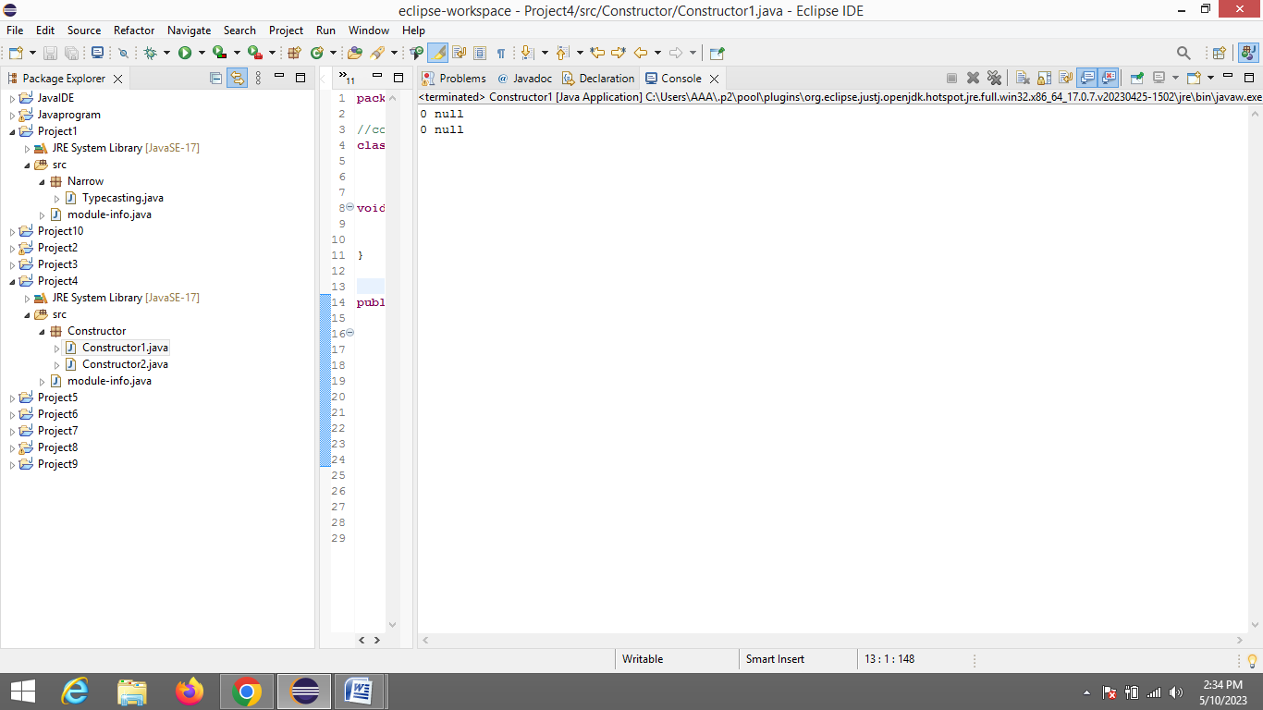

2) Parameterized Constructor

**package** Constructor;

//parameterized

**class** Std{

**int** id;

String name;

Std(**int** i,String n)

{

id =i;

name =n;

}

**void** display() {

System.***out***.println(id+" "+name);

}

}

**public** **class** Constructor2 {

**public** **static** **void** main(String[] args) {

Std std=**new** Std(20,"Siri");

Std std1=**new** Std(40,"Rama");

std.display();

std1.display();

}

}

